**A short report documenting the steps you took to deploy your WordPress website on AWS.**

1. Create an EC2 instance.
2. Assign the instance an Elastic IP Address
3. Use either terminal or MobaXterm to connect to your instance using the Public IP address of that instance.

**When connected, use the following commands to setup your wordpress website:**

1. Install Apache server on Ubuntu.
   1. sudo apt install apache2
2. Install php runtime and php mysql connector.
   1. sudo apt install php libapache2-mod-php php-mysql
3. Install MySQL server.
   1. sudo apt install mysql-server
4. MYSQL SETUP:
   1. Login to MySQL server
      1. sudo mysql -u root
   2. Change authentication plugin to mysql_native_password (change the password to something strong)
      1. ALTER USER 'root'@'localhost' IDENTIFIED WITH mysql_native_password by 'Testpassword@123';
   3. Create a new database user for wordpress (change the password to something strong)
      1. CREATE USER 'wp_user'@localhost IDENTIFIED BY 'Testpassword@123';
   4. Create a database for wordpress
      1. CREATE DATABASE wp;
   5. Grant all privilges on the database 'wp' to the newly created user
      1. GRANT ALL PRIVILEGES ON wp.* TO 'wp_user'@localhost;
5. Download WordPress.
   1. cd /tmp
   2. wget https://wordpress.org/latest.tar.gz
6. Unzip.
   1. tar -xvf latest.tar.gz
7. Move WordPress folder to Apache document root.
   1. sudo mv wordpress/ /var/www/html
8. After that go to the link.
   1. <your public ip address>/wordpress
9. It will ask you for the database details.

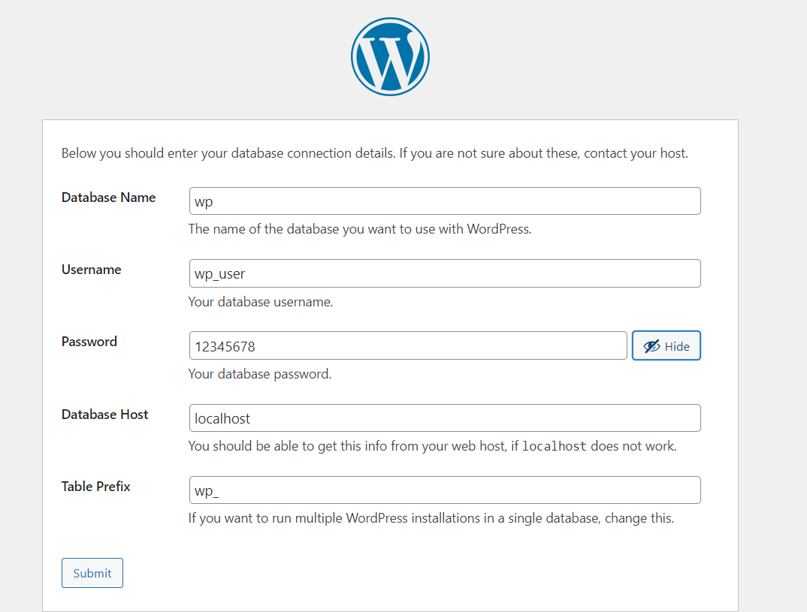

1. This will give you php code for wp-config file.
2. Go back to the terminal connected to your instance and run the following commands.
   1. cd /var/www/html/wordpress/
   2. nano wp-config.php
3. Paste the code in it and Refresh the site. It will ask for information about the site.
4. Set it up according to your liking.
5. You will the wordpress website up and running on your instance.

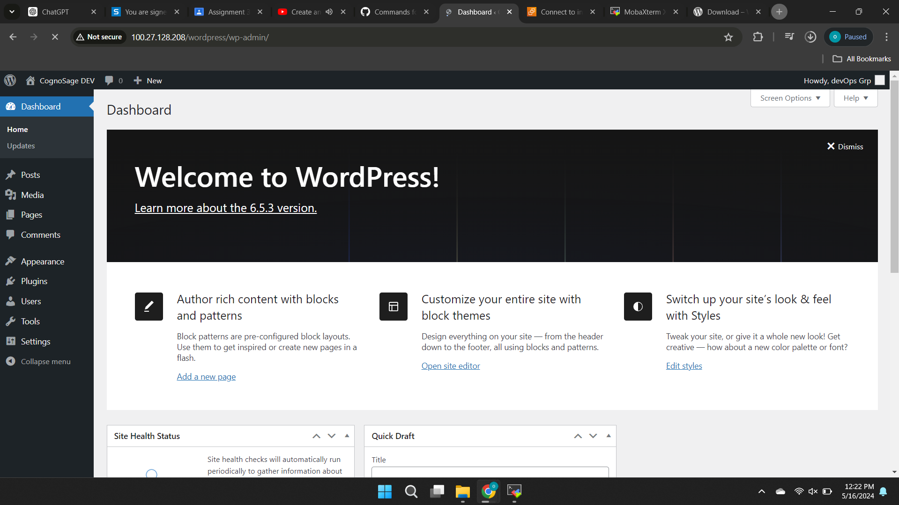

**Public/External IP address on which our website is deployed:**

**http://100.27.128.208/wordpress/**